Day 5: Troubleshooting Network Services Practical
Q1.Simulate a DNS resolution failure on your local machine by editing the hosts file to point www.spotify.com to a wrong IP address, then try to ping the domain and document the error message you receive.
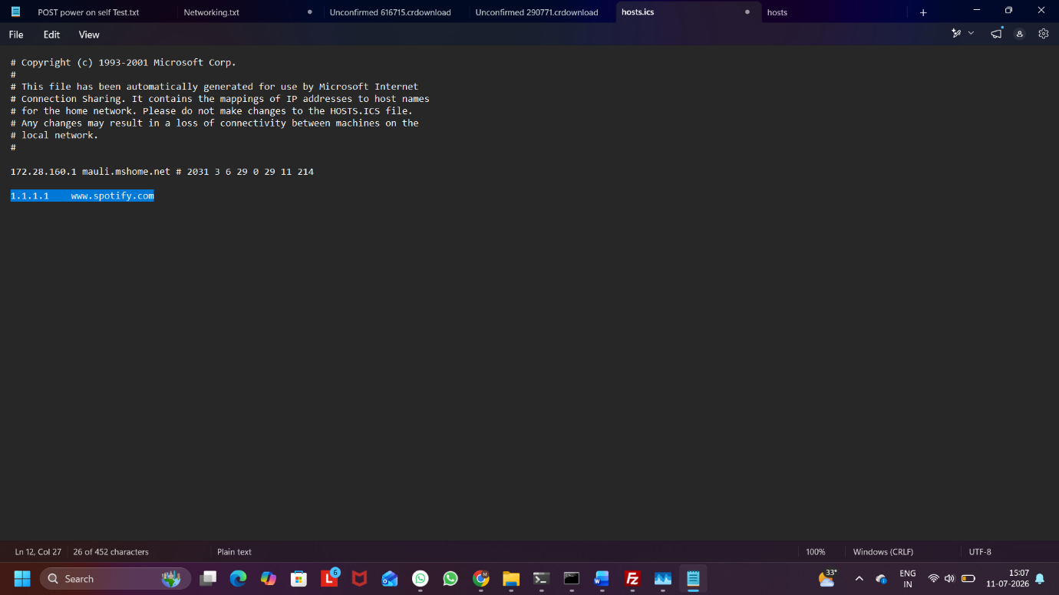
Ans:
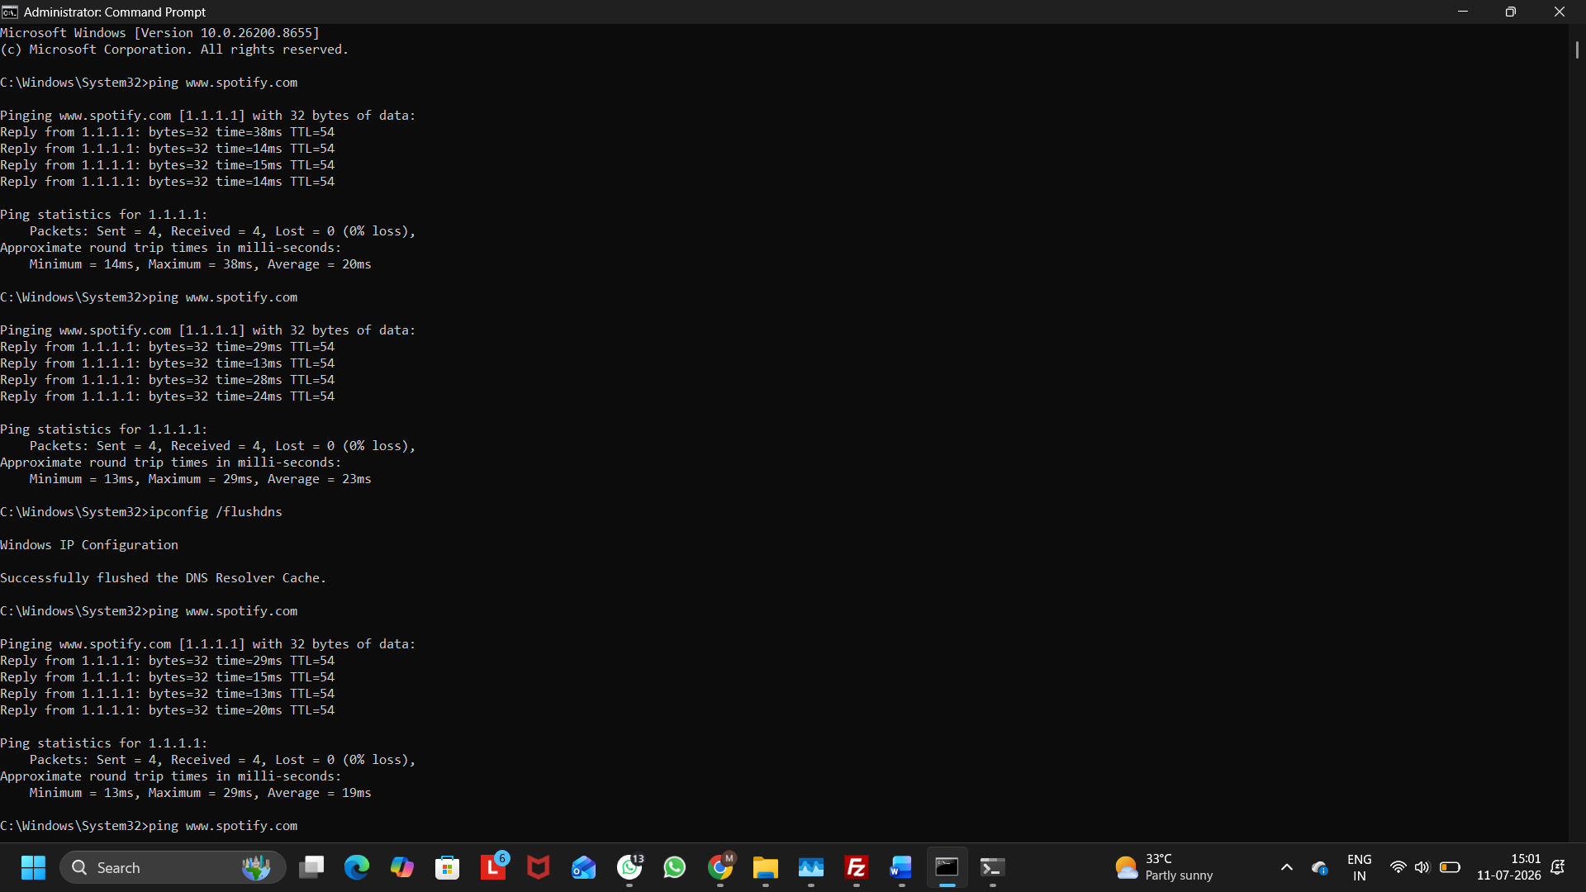
Figure1: Adding an Incorrect IP Address for www.spotify.com
Figure 2: Ping Result Showing www.spotify.com Resolved to 1.1.1.1
Observed Output
After modifying the hosts file and flushing the DNS cache, the ping command resolved www.spotify.com to the incorrect IP address 1.1.1.1 instead of its actual server address.
Note: In this experiment, no error message was displayed. Instead, the domain was resolved to the incorrect IP address (1.1.1.1), which demonstrated the effect of the incorrect hosts file mapping.

Q2. Configure a DHCP server in a network simulator (such as Cisco Packet Tracer or GNS3) and intentionally set an incorrect default gateway; connect a client device and verify the assigned gateway, then describe how you would identify and fix this issue.
Ans:
Step 1: Create the Network Topology
- Place one Server, one Switch, and one PC in Cisco Packet Tracer.
- Connect the Server and PC to the Switch using Copper Straight-Through cables.
Step 2: Configure the Server IP Address
Configure the Server with the following settings:
- IP Address: 192.168.1.2
- Subnet Mask: 255.255.255.0
- Default Gateway: 192.168.1.1
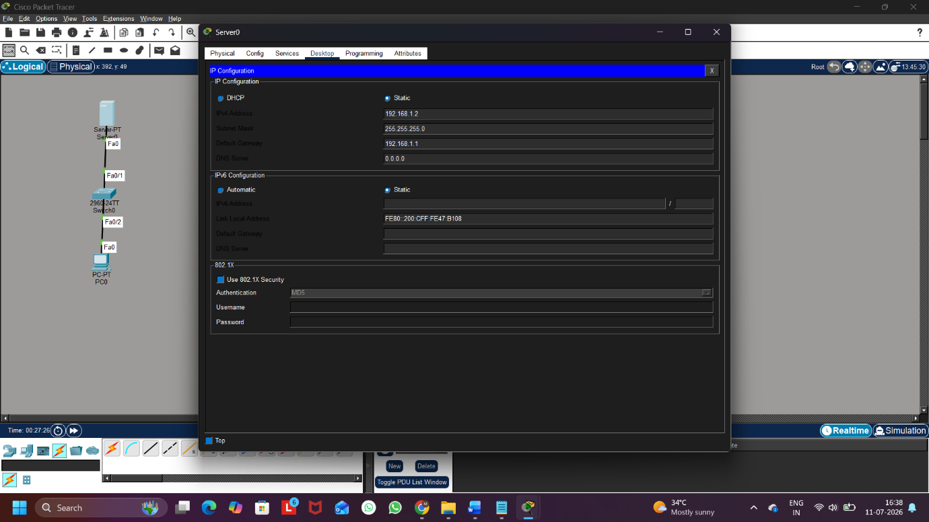
Figure 1: Server IP Configuration
Step 3: Configure the DHCP Server
Enable the DHCP service and configure the DHCP pool with the following details:
- Pool Name: Office
- Default Gateway: 192.168.1.254 (Incorrect – Intentionally)
- Start IP Address: 192.168.1.10
- Subnet Mask: 255.255.255.0
- DNS Server: 8.8.8.8
- Maximum Users: 50
Click Add to save the DHCP pool.
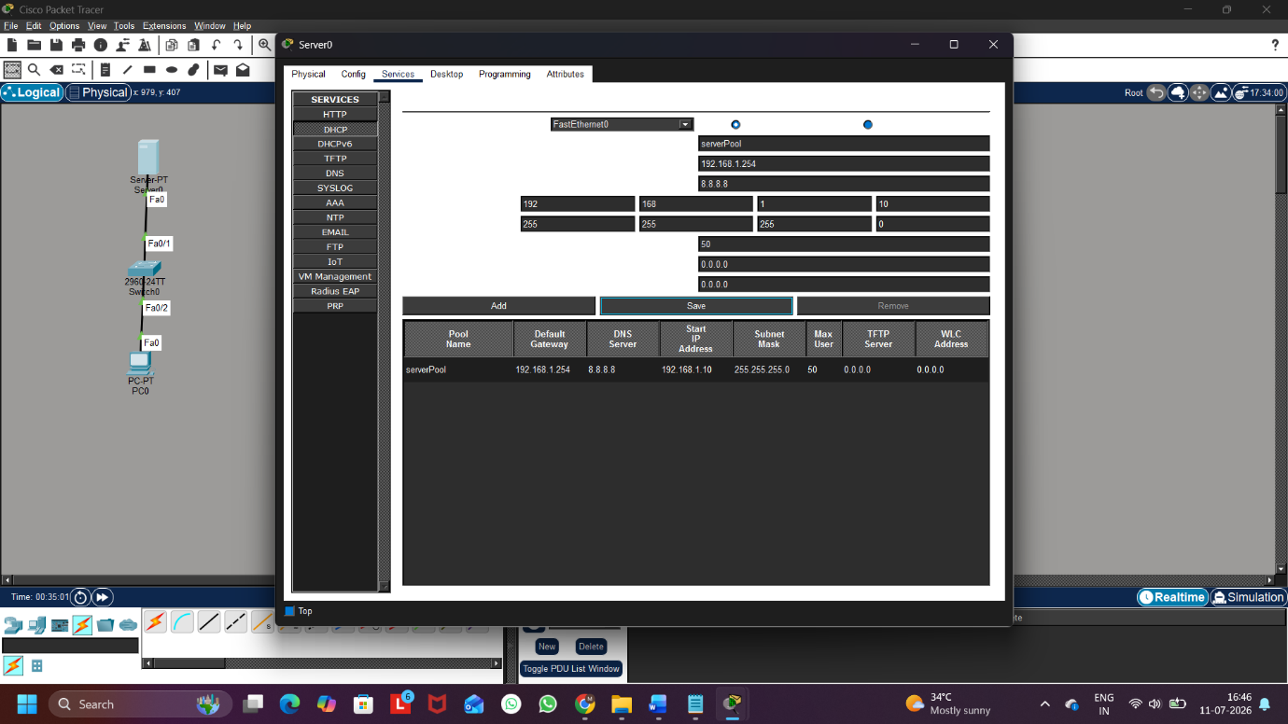
Figure 2: DHCP Pool Configuration with Incorrect Default Gateway

Step 4: Obtain an IP Address on the Client PC
Configure the PC to obtain an IP address automatically using DHCP.
The PC receives:
- IP Address: 192.168.1.10
- Subnet Mask: 255.255.255.0
- Default Gateway: 192.168.1.254
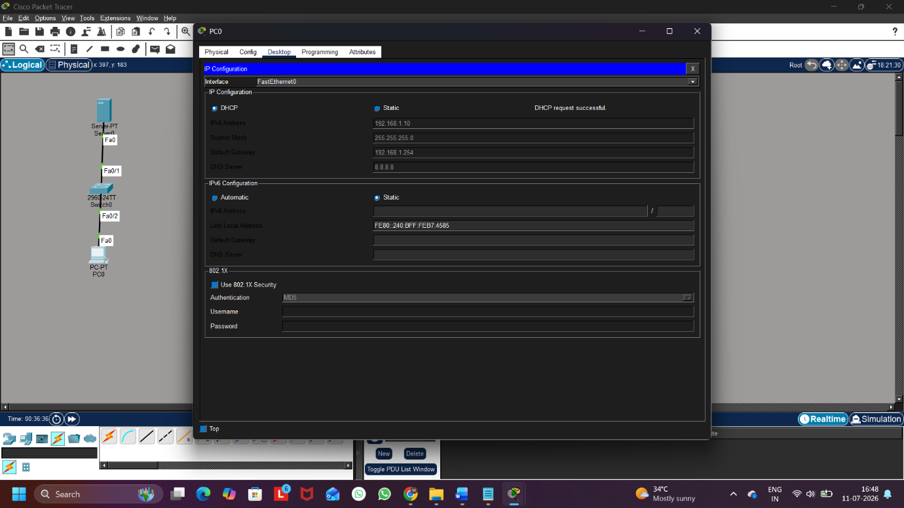
Figure 3: Client PC Receiving IP Address from DHCP

Step 5: Verify the Assigned Gateway
Open Command Prompt on the PC and execute the following command:
ipconfig
The output shows that the assigned Default Gateway is 192.168.1.254, confirming that the DHCP server has assigned the incorrect gateway.
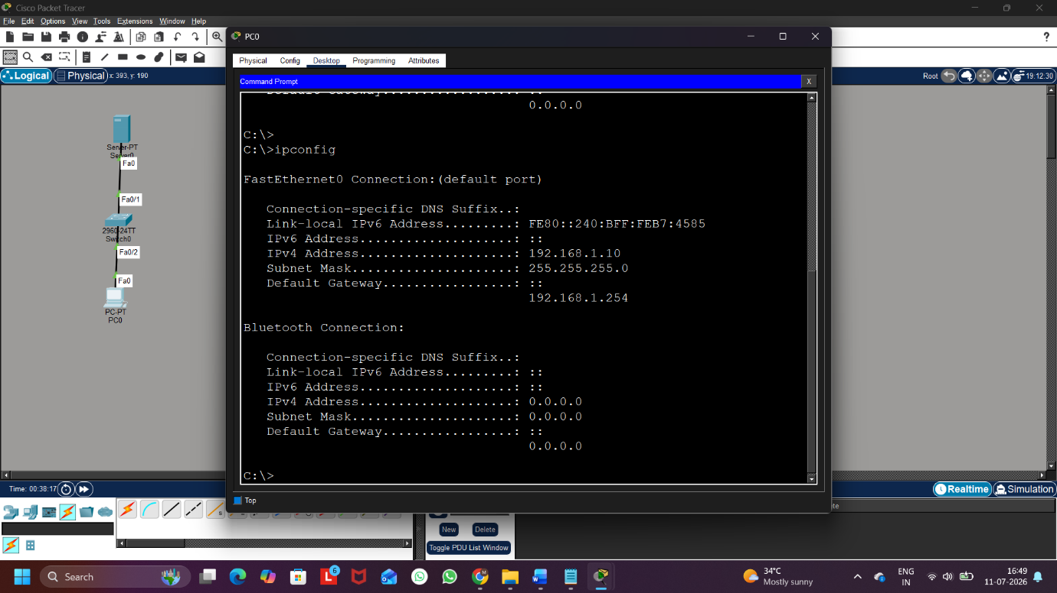
Figure 4: Verification of Assigned Gateway using ipconfig

Step 6: Correct the DHCP Configuration
Open the DHCP configuration on the Server and change the Default Gateway from:
192.168.1.254 ➜ 192.168.1.1
Save the updated configuration.
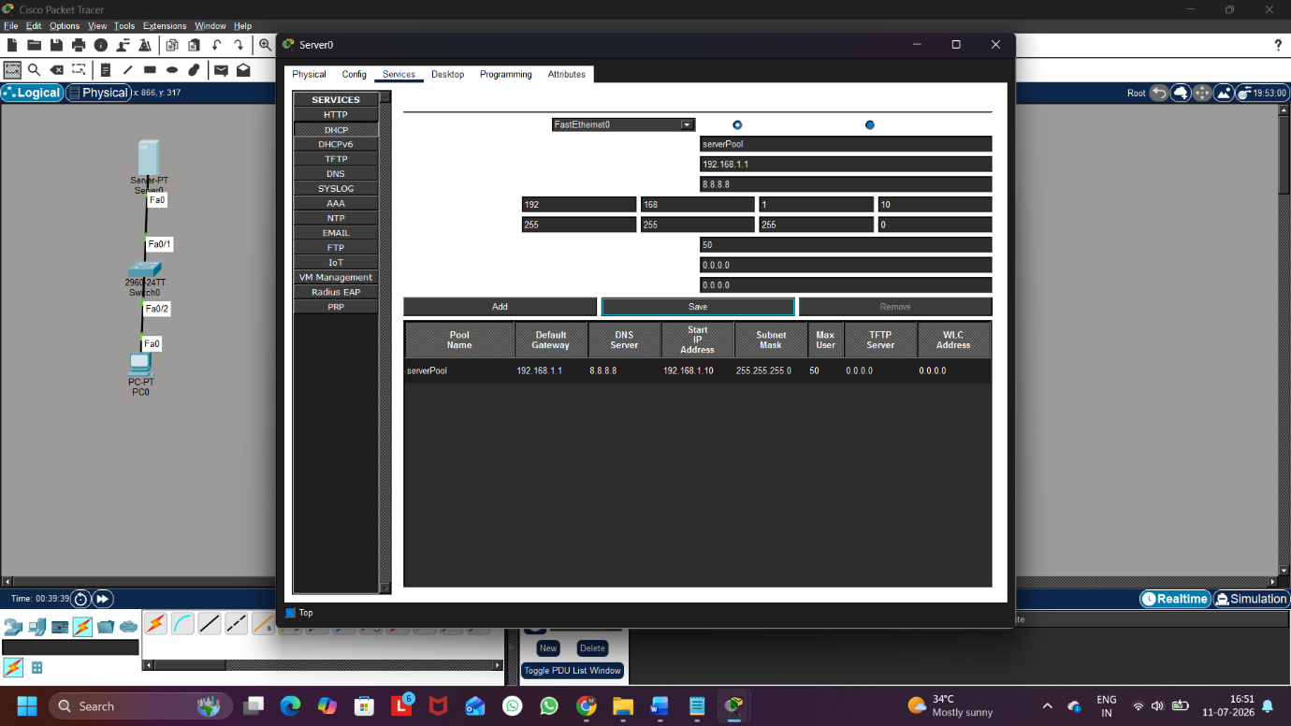
Figure 5: DHCP Configuration after Correcting the Default Gateway

Step 7: Renew the DHCP Configuration
Renew the IP configuration on the client PC and verify the updated network settings.
Execute:
ipconfig
The client now receives:
- IP Address: 192.168.1.10
- Default Gateway: 192.168.1.1
This confirms that the issue has been resolved successfully.
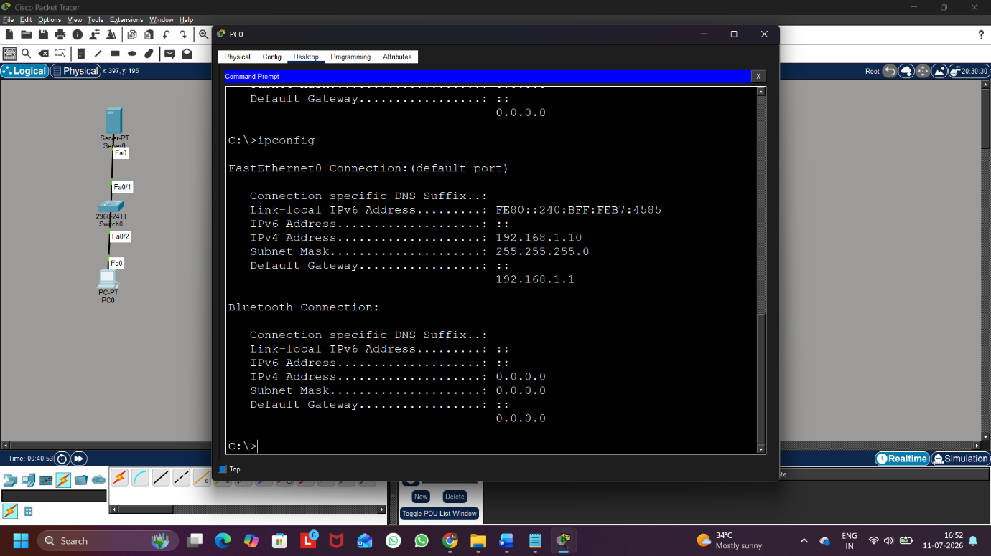
Figure 6: Verification after Correcting the Default Gateway

Q3. Given a scenario where devices on your simulated network are unable to access websites by name but can by IP address, use the nslookup or dig tool to diagnose the DNS problem and write down the troubleshooting steps and solution.
Ans:
Step 1: Create the Network Topology
A network consisting of one Server, one Switch, and one PC was created in Cisco Packet Tracer.

Step 2: Configure the Server
The Server was configured with the following settings:
- IP Address: 192.168.1.2
- Subnet Mask: 255.255.255.0
- Default Gateway: 192.168.1.1


Figure 1: Server IP Configuration

Step 3: Configure the DNS Service
The DNS service was enabled on the Server, and a DNS record was created.
- Domain Name: www.google.com
- IP Address: 192.168.1.50
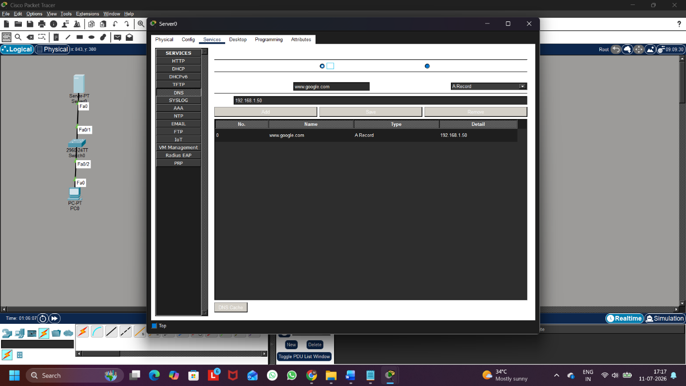
Figure 2: DNS Service Configuration

Step 4: Configure DHCP with an Incorrect DNS Server
The DHCP server was configured with the following settings:
- Pool Name: Office
- Default Gateway: 192.168.1.1
- Start IP Address: 192.168.1.10
- Subnet Mask: 255.255.255.0
- DNS Server: 192.168.1.100 (Incorrect – Intentionally)
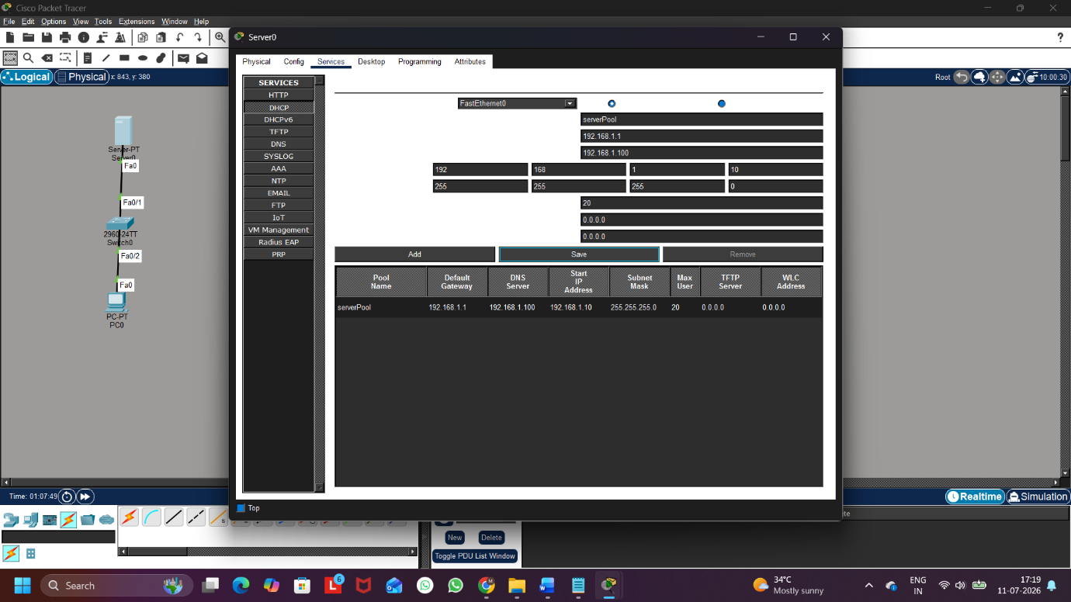
Figure 3: DHCP Configuration with Incorrect DNS Server

Step 5: Obtain Network Configuration on the Client
The client PC was configured to obtain its IP address automatically using DHCP.
The client received the incorrect DNS Server address.

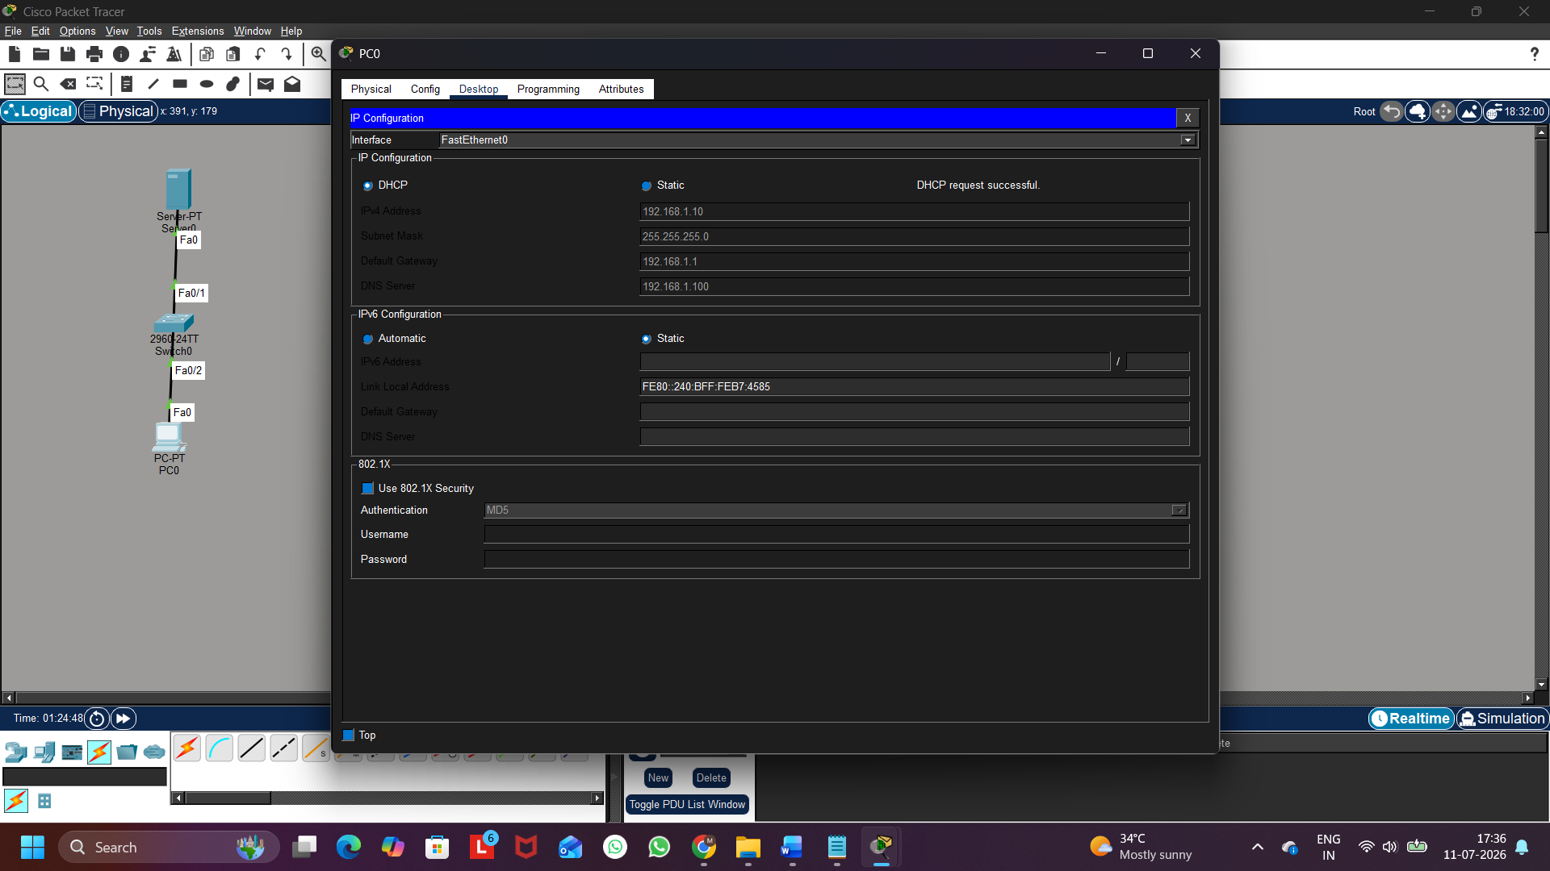
Figure 4: Client IP Configuration

Step 6: Diagnose the DNS Problem
The nslookup command was executed on the client PC.
nslookup www.google.com
The lookup failed because the client was using the incorrect DNS Server (192.168.1.100), resulting in a DNS request timeout.
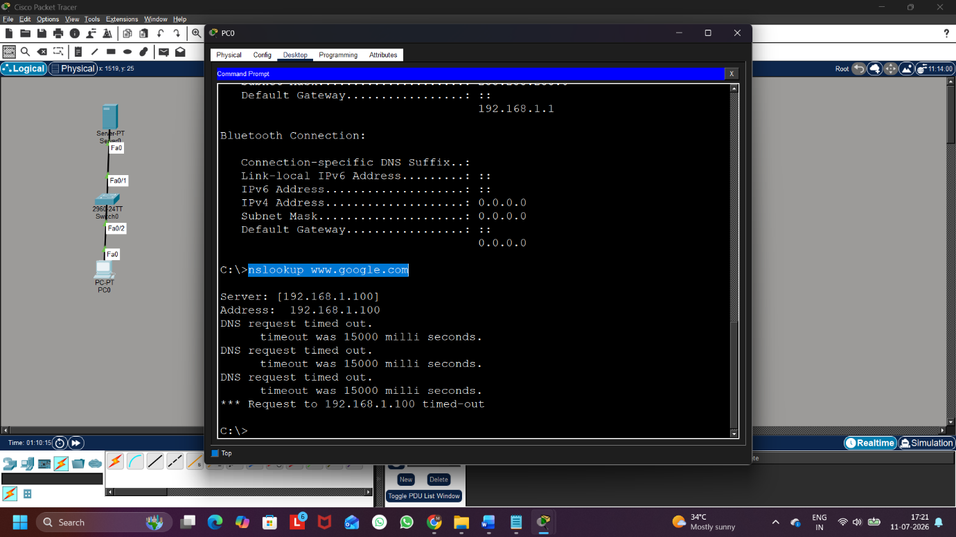
Figure 5: DNS Lookup Failure Using nslookup
Step 7: Correct the DNS Configuration
The DNS Server address in the DHCP configuration was changed from:
192.168.1.100 ➜ 192.168.1.2
The client renewed its DHCP configuration to obtain the updated DNS Server.
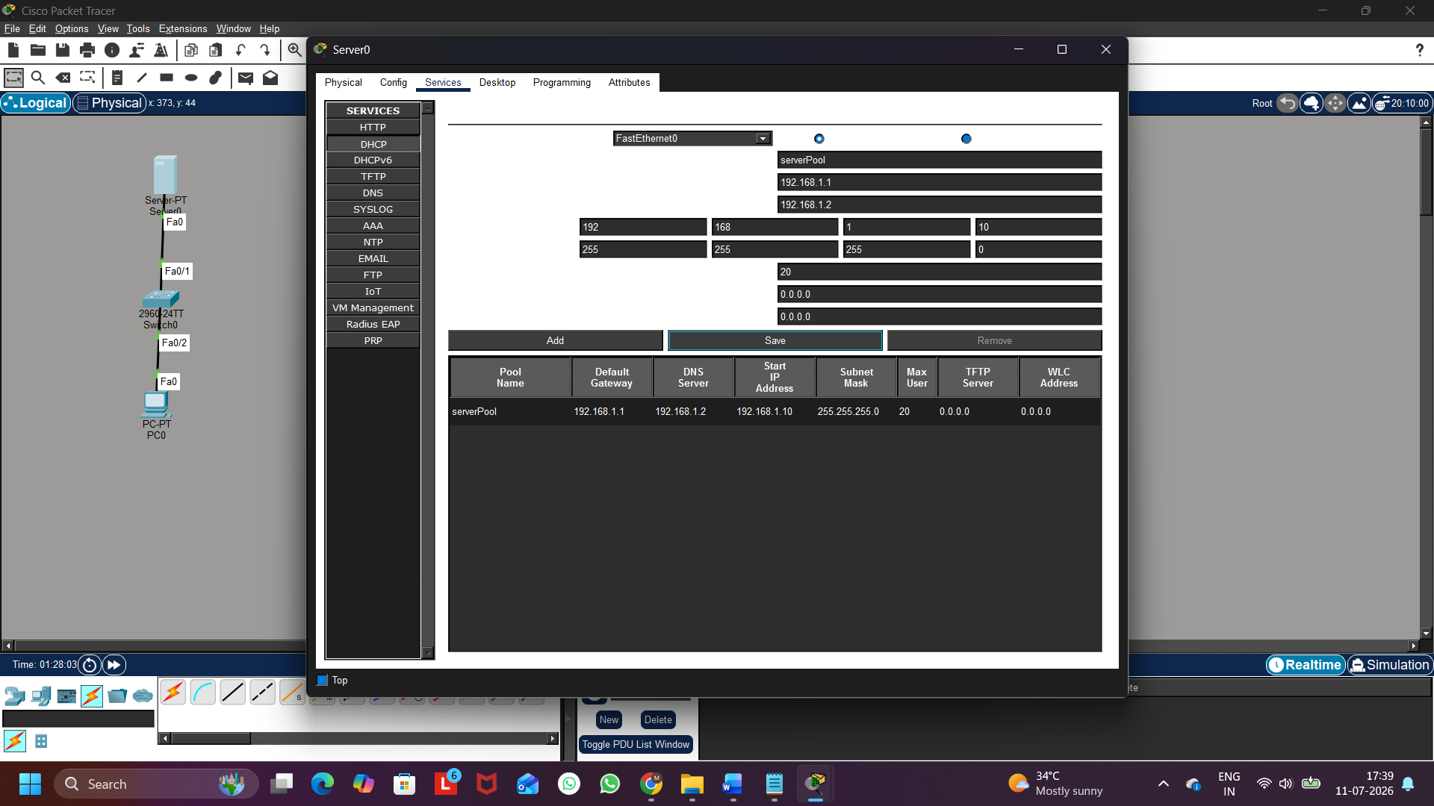
Figure 6: Correct DHCP DNS Configuration

Step 8: Verify the Solution
The nslookup command was executed again.
nslookup www.google.com
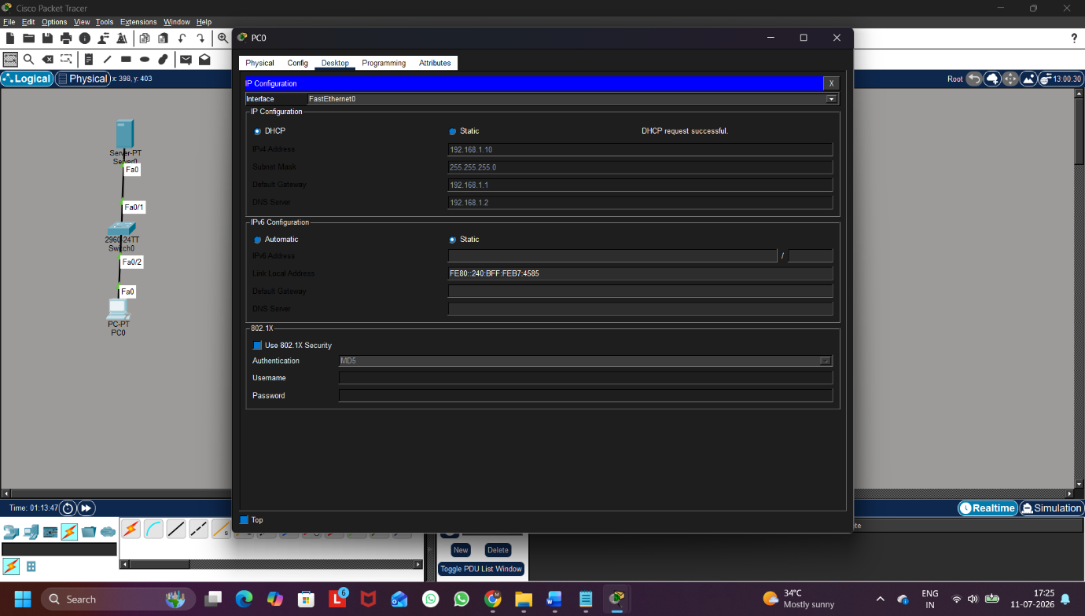
The domain name was successfully resolved to 192.168.1.50, confirming that the DNS issue had been resolved.
Figure 7: Successful DNS Lookup
Q4. A device in your simulated network is not receiving an IP address from the DHCP server and shows an APIPA address (169.x.x.x). List the possible causes for this and document the step-by-step process you would use to resolve it.<br><br><em><strong>Hint:</strong> Check for network connectivity, DHCP scope exhaustion, and server availability.</em>
Ans:
Step 1: Create the Network Topology
A network consisting of one Server, one Switch, and one PC was created.

Step 2: Configure the Server
The Server was configured with the following settings:
- IP Address: 192.168.1.2
- Subnet Mask: 255.255.255.0
- Default Gateway: 192.168.1.1

Step 3: Disable the DHCP Service
The DHCP service was intentionally turned OFF to simulate a DHCP failure.

Step 4: Observe the Client IP Address
The client PC was configured to obtain an IP address automatically.
Since the DHCP Server was unavailable, the client received an APIPA (169.254.x.x) address.

Step 5: Verify the Problem
The ipconfig command was executed on the client PC.
ipconfig
The output showed an IP address in the 169.254.x.x range, confirming that the client could not obtain an IP address from the DHCP server.

Step 6: Enable the DHCP Service
The DHCP service was enabled again, and the DHCP pool configuration was verified.

Step 7: Renew the Client IP Address
The client renewed its DHCP lease and successfully received a valid IP address from the DHCP server.

Possible Causes
- DHCP Server is turned OFF.
- Network cable is disconnected.
- Client and Server are not properly connected.
- DHCP address pool is exhausted.
- Incorrect DHCP configuration.
- Server is unavailable or powered OFF.
- Network interface is disabled.

Troubleshooting Steps
- Check the physical network connection.
- Verify that the DHCP Server is powered ON.
- Confirm that the DHCP Service is enabled.
- Check whether the DHCP address pool has available IP addresses.
- Verify the DHCP pool configuration.
- Renew the client's IP address.
- Use the ipconfig command to verify the assigned IP address.

Q5. Create a table documenting at least three common DNS issues and three common DHCP issues you encountered or researched, including symptoms, possible causes, and recommended solutions for each.
Ans:
Table 1: Common DNS Issues
Sr. No. | DNS Issue | Symptoms | Possible Causes | Recommended Solution
1 | Incorrect DNS Server Address | Websites cannot be accessed using domain names, but they can be accessed using IP addresses. | Wrong DNS server configured on the client or DHCP server. | Configure the correct DNS server address and renew the network settings.
2 | DNS Server Unavailable | DNS lookup fails and nslookup shows "Request timed out". | DNS server is offline, unreachable, or the DNS service is stopped. | Ensure the DNS server is running and network connectivity is available.
3 | Incorrect DNS Record | A website opens the wrong server or cannot be found. | Missing or incorrect DNS record in the DNS server. | Create or update the correct DNS record in the DNS server.

Table 2: Common DHCP Issues
Sr. No. | DHCP Issue | Symptoms | Possible Causes | Recommended Solution
1 | Client Receives APIPA Address (169.254.x.x) | The client receives a 169.254.x.x IP address instead of a valid network IP. | DHCP server is unavailable, DHCP service is disabled, or the client cannot reach the server. | Enable the DHCP server, verify connectivity, and renew the IP address.
2 | Incorrect Default Gateway Assigned | The client receives an IP address but cannot communicate outside the local network. | Incorrect default gateway configured in the DHCP scope. | Update the DHCP scope with the correct default gateway and renew the client's IP configuration.
3 | DHCP Scope Exhaustion | New devices fail to obtain an IP address from the DHCP server. | All available IP addresses in the DHCP scope have been assigned. | Increase the DHCP address pool or release unused IP addresses.

